[NLP & IR]
IR model evaluation
박철오 | 20212816

1. IR system showcases
1.1 Queries Testing
1.2 Precision & Recall measurement
2. Experiences & Suggestions

1. IR system showcases
1.1 Queries Testing
#1
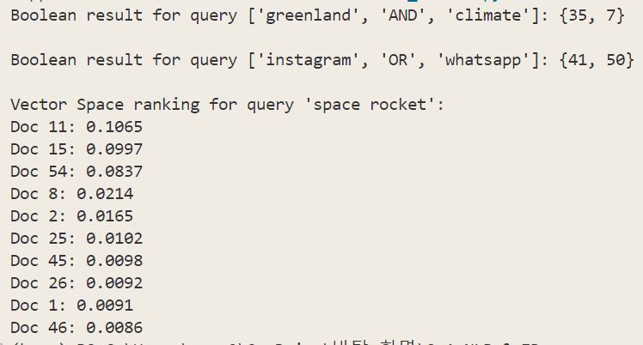
#2
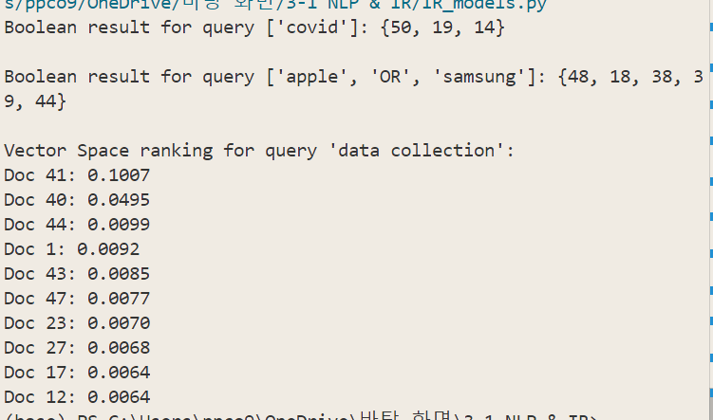
#3

1.2 Precision & Recall measurement
## Five types of queries different in broadness were chosen after several trials.
i) Very Broad Query
- “space” : included many relevant documents.
Precision : 21/23, while most documents aligned with my intended meaning of ‘space’, a few were somewhat off-topic, seemingly inevitable when the query is too general and broad.
Recall : 21/28, There still were some documents left behind even though they were related to the query. This case clearly shows that Boolean model is bound to miss relevant documents just because there wasn’t a single exact match.

- “data” : demonstrating a common single-term query’s coverage
Precision : 5/23, There seemed to be too many unrelated documents simply containing the term “data”.
Recall : 5/6 : Out of the candidates I was expecting, most were successfully retrieved.

ii) Moderately Broad Query
- “space AND mars” : slightly narrowed from the result of querying with “space”
Precision : 9/10, with common word ‘space’ and specific name ‘mars’, it was possible to correctly retrieve the desired documents. There still was an unwanted document simply mentioning the query terms but not strictly about them.
Recall : 9/9, All the documents that I thought they be retrieved were successfully retrieved.

iii) Intermediate-Specific Query
- “media AND data” : much filtered from the result of “data” as query
Precision : 2/3. Expected two, but one simply containing the terms came into the result.
Recall : 2/3. One document was missing in the expected result. Another example of rigidness that it must include the exact query term.

iii) Narrow Technical Query
- “spintronic” : example of a domain-specific terminology used as a query
Both precision and recall are 1 since this document was the one and only document related to given query.

iv) Compound Query
- “galaxy AND NOT spacex OR ai” :
Precision : 8/9. Was a reasonable result but still had a document not quite fitting the query.
Recall : 8/12. Depending on the boundary of the term ‘galaxy’, there seemed to be some documents that are reasonable to be in the result. Other terms served as strict criteria.

2. Experiences & Suggestions
i) Experiences :
- There are many words with multiple definitions. Since the model does not take into account the definition I implied by a word, it often included irrelevant documents resulting in a decrease in precision.
- Because POS is not being considered, especially whether a term is a proper noun or not, it sometimes mixes a proper noun with common noun, failing to capture the true meaning. Assumed to be the major problem that decreased precision.
- My current model takes input in lowercase which lacks flexibility in distinguishing between proper noun and common noun, sometimes even missing words that are capitalized for emphasis.
- Boolean model was feasible in checking whether all the terminologies were included in the document. Domain-specific terms seemingly worked well along with ANDs for tight narrowing and bounding. Both precision and recall increased by doing so.
- Very rigid and lacking flexibility : documents do not go under consideration unless containing exact matches. Result is an unranked set of documents. Assumed to be the major problem that decreased recall.
- Does not capture the context since the model simply serves as a filter.
ii) Suggestions :
- Like what attentions are used for in transformer models, Boolean model can incorporate another layer to highlight the relation between words, eventually making it easier to disambiguate the meaning of homonym.
- In quick filtering operations, Boolean models can come into play.
- Relaxing on the strictness of input query or logical operators. For example, include variants of a verb for flexibility.

